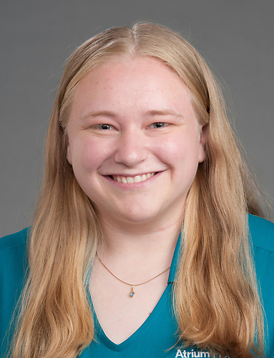 | Julianna Blatz, MS, LAT, ATC
 | Head Athletic Trainer High Point Central High School
 | 336-813-2733
 | jblatz@wakehealth.edu
 | blatzj@gcsnc.com
 | https://www.wakehealth.edu/specialty/s/sports-medicine/athletic-trainer-program
Julianna Blatz is a valuable member of the Atrium Health Wake Forest Baptist Athletic Training Outreach Program. She is assigned to High Point Central High School in High Point, North Carolina. Julianna is a BOC (Board of Certification) certified athletic trainer and licensed by the State of North Carolina.

Julianna is from Riverton, New Jersey. She graduated from West Chester University (Pennsylvania) in December 2021 and May 2023. Her Master’s degree is in Athletic Training and her bachelor’s degree is in Health Sciences with a concentration in Sports Medicine.

Julianna is in her first year at Central as the head athletic trainer. She is extremely excited to be a part of the Sports Medicine team at Atrium Health Wake Forest Baptist and work as the Athletic Trainer at High Point Central High School.

Go Bison!!!!

